Computer Networks Laboratory

Assignment 1

Name: Anirban Das Class: BCSE-III Roll: 001910501077 Group: A3

Problem Statement:

Design and Implement an Error Detection Module

Design and implement an error detection module which has four schemes namely LRC, VRC, Checksum and CRC. Please note that you may need to use these schemes separately for other applications (assignments). You can write the program in any language. The Sender program should accept the name of a test file (contains a sequence of 0,1) from the command line. Then it will prepare the data frame (decide the size of the frame) from the input. Based on the schemes, codeword will be prepared. Sender will send the codeword to the Receiver. Receiver will extract the dataword from codeword and show if there is any error detected. Test the same program to produce a PASS/FAIL result for following cases:

(a) Error is detected by all four schemes. Use a suitable CRC polynomial.
(b) Error is detected by checksum but not by CRC.
(c) Error is detected by VRC but not by CRC.

[Note: Inject error in random positions in the input data frame. Write a separate method for that.]

Submission Date: 12th August, 2021.

Deadline:

Design:

The assignment mainly focusses on error detection modules written in Python.
All the modules and files used are briefly explained below:

There are two classes, namely Sender and Receiver. The Sender object contains datawords and codewords of 32 bits (customizable by user input). It also has four encoding functions based on the schemes which are used to check for error while transmitting the data. The Receiver object gets initialized with a Sender object (for storing the received codewords sent by the server). It also has a checkError() function which detects error (if any) based on the scheme which is decided before sending the codewords. There is also a function to calculate the accuracy of each scheme which is discissed later in the report.

The simulation is managed using Socket Programming in Python using the “socket” library. There is a server which contains the main Sender object. It also has three “error injecting” functions (random_position_error, specific_position_error, random_burst_error). There are three different “cases” for this assignment which are handled in three different functions in the server. There are 4 different clients (each for a single scheme). Once the server is started, a client can connect with it, by sending its corresponding “scheme id”. Once a connection is made, the codewords (after injecting error) are sent from the server. There is Receiver object associated with each of the clients. The codewords are used to initialize the Receiver object, and the error detection proceeds. Once detection is complete, the packets are received sending a PASS signal (acknowledgement) to the Sender. Otherwise, if an error is detected in any of the packets, a FAIL signal is sent to the Sender and the packets are discarded.

The accuracy of each scheme is calculated after the detection of errors is finished, i.e. every codeword has been checked by the receiver.

The error detection schemes used are:

1. Longitudinal Redundancy Check (LRC).
2. Vertical Redundancy Check (VRC).
3. CheckSum.
4. Cyclic Redundancy Check (CRC).

[ Note: Basic operations such as binary additions, divisions, etc. are implemented in a separate utility file explained later in the report. ]
The following structure diagram shows the procedural organization of the program as explained in the previous paragraph:

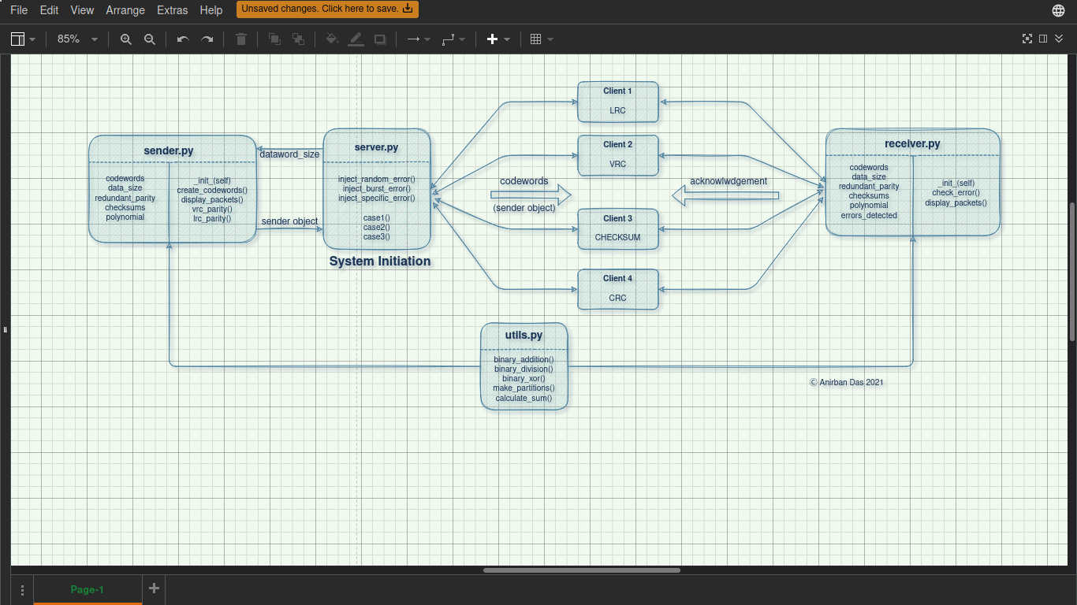
Flow Diagram of Modules Implemented for the Assignment

The main driver files have different I/O formats. The following list explains them briefly:

1. server: This is the initiating file for the system. To run this file, the user must provide a “filename” in the command prompt. The file will be used to store a random string of bits which in turn is used as our datawords. It starts with a “menu” of cases to be selected from. The user can enter 1, 2, 3 or 4 based on the list of cases explained in the problem statement (4 being exit). For the case 1, the user needs to then enter a “size input” for the datawords (multiples of 8 are preferred). Whenever a connection is made with a receiver (client), this file outputs the address of the connection along with the data words and codewords in its terminal.

2. clients: There are four clients in this design as explained earlier. Each of the clients, after connecting to the server, displays a message for each codeword received by it from the sender (server). The message is either “Error Detected” or “No Error Detected”. It aslo displays the codewords (error injected or error-free) received as a list. After the completion of the error detection process it shows an accuracy measurement for its corresponding “error scheme”. There is no such user “input” for the clients, as it receives a Sender object from the server before sending it to its corresponding Receiver object.

[ Note: The server & clients use socket to communicate with each other. Python’s socket module is used to implement such an enviornment where data transfer is made via ports and sockets ]
Implementation:

Code Snippets

° sender.py

class Sender:
def __init__(self, size):
self.codewords = []
self.size = size
self.redundant_parity_byte = ""
self.checksums = []
self.polynomial = ""

def create_codewords(self, file_name, scheme, polynomial=""):
file = open(file_name, "r")
packet = file.readline()
file.close()

if scheme == "LRC":
self.codeword_util(packet)
self.lrc_parity_generator()

elif scheme == "VRC":
self.codeword_util(packet)
self.vrc_parity_generator()

elif scheme == "CHECKSUM":
self.codeword_util(packet)
for i in range(len(self.codewords)):
divisions = make_divisions(self.codewords[i])
sum_of_divisions = calculate_sum(divisions)
checksum = ""
for j in range(len(sum_of_divisions)):
if sum_of_divisions[j] == '0':
checksum += '1'
else:
checksum += '0'
self.checksums.append(checksum)

elif scheme == "CRC":
self.polynomial = polynomial
self.crc_codeword_util(packet, polynomial)

def display_packets(self, scheme):
data_words = []
for x in self.codewords:
data_words.append(x[:self.size])
print("Data-Words:")
print(data_words)
print("Code-Words Sent by Sender:")
print(self.codewords)
if scheme == "CRC":
print("Polynomial Used: ", self.polynomial)
print("\n")

def codeword_util(self, packet):
temp_word = ""
for index in range(len(packet)):
if index != 0 and index % self.size == 0:
self.codewords.append(temp_word)
temp_word = ""
temp_word += packet[index]
self.codewords.append(temp_word)

def crc_codeword_util(self, packet, polynomial):
temp_word = ""
data_size = self.size
for index in range(len(packet)):
if index > 0 and index % data_size == 0:
temp_word += '0' * (len(polynomial) - 1)
remainder = binary_division(temp_word, polynomial)
remainder = remainder[len(remainder) - (len(polynomial) - 1):]
temp_word = temp_word[:data_size]
temp_word += remainder
self.codewords.append(temp_word)
temp_word = ""

temp_word += packet[index]

temp_word += '0' * (len(polynomial) - 1)
remainder = binary_division(temp_word, polynomial)
remainder = remainder[len(remainder) - (len(polynomial) - 1):]
temp_word = temp_word[:data_size]
temp_word += remainder
self.codewords.append(temp_word)

def vrc_parity_generator(self):
for i in range(len(self.codewords)):
one_count = 0
for j in range(len(self.codewords[i])):
if self.codewords[i][j] == '1':
one_count += 1
if one_count % 2 == 1:
self.codewords[i] += '1'
else:
self.codewords[i] += '0'

def lrc_parity_generator(self):
for i in range(len(self.codewords)):
count1 = 0
count2 = 0
for j in range(0, len(self.codewords[i]), 2):
if self.codewords[i][j] == 1:
count1 += 1
for j in range(1, len(self.codewords[i]), 2):
if self.codewords[i][j] == 1:
count2 += 1
if count1 % 2 == 1:
parity1 = "1"
else:
parity1 = "0"
if count2 % 2 == 1:
parity2 = "1"
else:
parity2 = "0"
self.codewords[i] += parity1 + parity2

° receiver.py:

class Receiver:
def __init__(self, sender):
self.codewords = sender.codewords
self.size = sender.size
self.actual_redundant_parity_byte = sender.redundant_parity_byte
self.received_redundant_parity_byte = ""
self.actual_checksums = sender.checksums
self.checksums = []
self.polynomial = sender.polynomial
self.accuracy = 0

def check_error(self, scheme, polynomial=""):
if scheme == "VRC":
for i in range(len(self.codewords)):
one_count = 0
for j in range(len(self.codewords[i])):
if self.codewords[i][j] == '1':
one_count += 1
if one_count % 2 == 1:
print("Parity is ODD. ERROR DETECTED.")
self.accuracy += 1
else:
print("Parity is EVEN. NO ERROR DETECTED.")

elif scheme == "LRC":
is_error = False
for i in range(len(self.codewords)):
count1 = 0
count2 = 0
parity = self.codewords[i][32:]
# print(parity)
for j in range(0, len(self.codewords[i][:32]), 2):
if self.codewords[i][j] == 1:
count1 += 1
for j in range(1, len(self.codewords[i][:32]), 2):
if self.codewords[i][j] == 1:
count2 += 1
if count1 % 2 == 1:
parity1 = "1"
else:
parity1 = "0"
if count2 % 2 == 1:
parity2 = "1"
else:
parity2 = "0"

if parity1 != parity[0] or parity2 != parity[1]:
is_error = True

if is_error:
print("Parity not matched. ERROR DETECTED.")
self.accuracy += 1
else:
print("Parity matched. NO ERROR DETECTED.")

elif scheme == "CHECKSUM":
for i in range(len(self.codewords)):
divisions = make_divisions(self.codewords[i])
sum_of_divisions = calculate_sum(divisions)
sum_of_divisions = binary_addition(sum_of_divisions, self.actual_checksums[i])
checksum = ''
for j in sum_of_divisions:
if j == '1':
checksum += '0'
else:
checksum += '1'

is_error = False
if int(checksum, 2) != 0:
is_error = True
if is_error:
print("Complement is non-zero. ERROR DETECTED.")
self.accuracy += 1
else:
print("Complement is zero. NO ERROR DETECTED.")

elif scheme == "CRC":
for index in range(len(self.codewords)):
remainder = binary_division(self.codewords[index], polynomial)
is_error = False
for j in range(len(remainder)):
if remainder[j] == '1':
is_error = True
print("Remainder:", remainder, end=' ')
if is_error:
print("ERROR DETECTED")
self.accuracy += 1
else:
print("NO ERROR DETECTED")
print()

def display_packets(self, scheme):
print("Code-Words Received by Receiver:")
print(self.codewords)
if scheme == "CRC":
print("Polynomial Used: ", self.polynomial)
print("Accuracy: ", self.accuracy, "%")
print("\n")

° utils.py:

LENGTH_OF_DIVISIONS = 4

def binary_addition(binary1, binary2):
result = ""
i = len(binary1) - 1
j = len(binary2) - 1
carry = 0
while i >= 0 or j >= 0 or carry == 1:
if i >= 0:
carry += int(binary1[i])
if j >= 0:
carry += int(binary2[j])
result = str(carry % 2) + result
carry = carry // 2
i = i - 1
j = j - 1
return result

def binary_xor(binary1, binary2):
answer = ""
for index in range(1, len(binary2)):
if binary1[index] == binary2[index]:
answer += '0'
else:
answer += '1'

return answer

def binary_division(dividend, divisor):
length_of_xor = len(divisor)
remainder = dividend[:length_of_xor]
while len(dividend) > length_of_xor:
if remainder[0] == '1':
remainder = binary_xor(divisor, remainder) + dividend[length_of_xor]
else:
remainder = binary_xor('0' * length_of_xor, remainder) + dividend[length_of_xor]
length_of_xor += 1

if remainder[0] == '1':
remainder = binary_xor(divisor, remainder)
else:
remainder = binary_xor('0' * length_of_xor, remainder)

return remainder

def make_divisions(codeword):
divisions = []
temp_word = ""
for i in range(len(codeword)):
if i > 0 and i % LENGTH_OF_DIVISIONS == 0:
divisions.append(temp_word)
temp_word = ""
temp_word += codeword[i]
divisions.append(temp_word)

return divisions

def calculate_sum(divisions):
answer = divisions[0]
for index in range(1, len(divisions)):
answer = binary_addition(answer, divisions[index])
while len(answer) > LENGTH_OF_DIVISIONS:
part1 = answer[:len(answer) - LENGTH_OF_DIVISIONS]
part2 = answer[len(answer) - LENGTH_OF_DIVISIONS:]
answer = binary_addition(part1, part2)
return answer

° server.py: (Interface)

def generate_random_bits(length, file_name):
file = open(file_name, "w")
for i in range(length):
file.write(str(random.randint(0, 1)))
file.close()

def inject_error_at_random_position(codewords):
# for i in range(len(codewords)):
random_codeword = random.randint(0, len(codewords) - 1)
random_position = random.randint(0, len(codewords[random_codeword]) - 1)
toggled_bit = "0" if codewords[random_codeword][random_position] == "1" else "1"
codewords[random_codeword] = codewords[random_codeword][:random_position] + toggled_bit + codewords[
random_codeword][
random_position + 1:]
return codewords

def inject_burst_error(codewords):
for index in range(len(codewords)):
no_of_errors = len(codewords[index]) - random.randint(1, 5)
for j in range(no_of_errors):
random_position = random.randint(0, len(codewords[index]) - 1)
toggled_bit = "0" if codewords[index][random_position] == "1" else "1"
codewords[index] = codewords[index][:random_position] + toggled_bit + codewords[index][random_position + 1:]

return codewords

def inject_specific_error(codewords, zeros_pos, ones_pos):
for i in range(len(zeros_pos)):
for j in range(len(zeros_pos[i])):
pos = zeros_pos[i][j]
codewords[i] = codewords[i][:pos] + '0' + codewords[i][pos + 1:]
for i in range(len(ones_pos)):
for j in range(len(ones_pos[i])):
pos = ones_pos[i][j]
codewords[i] = codewords[i][:pos] + '1' + codewords[i][pos + 1:]

return codewords

def case1(data_size, file_name):
s = socket.socket()
print("Socket Created Successfully")

port = 12345
s.setsockopt(socket.SOL_SOCKET, socket.SO_REUSEADDR, 1)

s.bind(('', port))
print("Socket binded to port ", port)

s.listen(5)

while True:
connection, address = s.accept()
print("\nConnection established with", address)

SCHEME_NAME = pickle.loads(connection.recv(1024))
print("\n**Encoding Data-Words using '", SCHEME_NAME, "' Encoding Scheme**")

if SCHEME_NAME != "CRC":
sender = Sender(data_size)
sender.create_codewords(file_name, SCHEME_NAME)
sender.display_packets(SCHEME_NAME)

temp = sender.codewords
sender.codewords = inject_burst_error(sender.codewords)

data_string = pickle.dumps(sender)

connection.sendall(data_string)

else:
polynomials = open('polynomials.txt').read().splitlines()
polynomial = random.choice(polynomials)

sender = Sender(data_size)
sender.create_codewords(file_name, SCHEME_NAME, polynomial)
sender.display_packets(SCHEME_NAME)

sender.codewords = inject_burst_error(sender.codewords)

data_list = [sender, polynomial]
data_list = pickle.dumps(data_list)

connection.sendall(data_list)

connection.close()

def case2(data_size, file_name):
...same as case1

if SCHEME_NAME == "CHECKSUM":
sender = Sender(data_size)
sender.create_codewords(file_name, SCHEME_NAME)
sender.display_packets(SCHEME_NAME)

sender.codewords = inject_specific_error(sender.codewords, zeros_pos, ones_pos)

data_string = pickle.dumps(sender)
connection.sendall(data_string)

elif SCHEME_NAME == "CRC":
polynomial = "1000"

sender = Sender(data_size)
sender.create_codewords(file_name, SCHEME_NAME, polynomial)
sender.display_packets(SCHEME_NAME)

sender.codewords = inject_specific_error(sender.codewords, zeros_pos, ones_pos)

data_list = [sender, polynomial]
data_list = pickle.dumps(data_list)

connection.sendall(data_list)

def case3(data_size, file_name):
.....same as case1

if SCHEME_NAME == "VRC":
sender = Sender(data_size)
sender.create_codewords(file_name, SCHEME_NAME)
sender.display_packets(SCHEME_NAME)

sender.codewords = inject_specific_error(sender.codewords, zeros_pos, ones_pos)

data_string = pickle.dumps(sender)
connection.sendall(data_string)

elif SCHEME_NAME == "CRC":
polynomial = "100"

sender = Sender(data_size)
sender.create_codewords(file_name, SCHEME_NAME, polynomial)
sender.display_packets(SCHEME_NAME)

sender.codewords = inject_specific_error(sender.codewords, zeros_pos, ones_pos)

data_list = [sender, polynomial]
data_list = pickle.dumps(data_list)

connection.sendall(data_list)
° client.py: (Interface) (There are four clients, all having the same generic code snippet)

from receiver import *

SCHEME_NAME = 'GENREIC_SCHEME_NAME'

s = socket.socket()

port = 12345

s.connect(('127.0.0.1', port))

s.send(pickle.dumps(SCHEME_NAME))

data = []
while True:
packet = s.recv(4096)
if not packet:
break
data.append(packet)
data_value = pickle.loads(b"".join(data))

if type(data_value) is str:
print("Invalid Connection!")

else:
receiver = Receiver(data_value)
receiver.check_error(SCHEME_NAME)
receiver.display_packets(SCHEME_NAME)

s.close()

Method Descriptions

sender.py:

1. create_codewords(self, filename, scheme, polynomial=””): The function takes a “filename” as argument, from which it reads the sequence of 1s and 0s for the datawords (ref: codeword_util()). The “scheme” parameter decides the type of error encoding scheme to be used to create the codewords from the above created datawords. The redundant bits are generated and stored in the Sender object. The “polynomial” refers to the CRC polynomial used during the encoding by CRC error detecting scheme.

2. codeword_util(self, packet): The size paraemter passed during the creation of Sender object is used to divide this sequence(“packet” parameter passed from create_codewords()) into a number of datawords of that size. The datawords are stored in an array in the Sender object.

3. vrc_parity_generator(self): This function uses VRC encoding scheme to generate an even parity
for each of the dataword. After generating the parity bit, it is appended at the back of the dataword to form a codeword.

4. lrc_parity_generator(self): This function uses LRC encoding scheme to generate codewords from datawords. The codeword is divided into two columns and size/2 rows. The parity (even) is calculated for both columns and is apended as a 2-bit redundant parity at the back of the dataword.

5. crc_codeword_util(self, packet, polynomial): This method uses CRC encoding scheme to generate codewords. In this method, dividend (codeword from “packet”) and divisor (“polynomial”) is taken as input from its arguments. For each codeword, a sequence of 0s of size of CRC – 1 is augmented at the end, then a binary division is performed using the polynomial on the codeword. The remainder is then augmented at the end of the codeword and then stored in the Sender object.

6. display_packets(self, scheme): This function displays the datawords and codewords generated by the “sender”. Depending on the “scheme”, it also displays the polynomial being used in case of CRC encoding.

receiver.py:

1. check_error(self, scheme, poynomial=””): This method takes “scheme” of error detection method as one of its argument. On the basis of the scheme the codewords received is checked for
error. If there is an error, appropriate message is displayed on the screen. This method also keeps a count of the errors detected as a measure of the accuracy of that “scheme”.

2. display_packets(self, scheme): This function displays the codewords received by the “receiver”. Depending on the “scheme”, it also displays the polynomial being used in case of CRC encoding. It also displays the accuracy of the scheme which is explained later in the report.

utils.py:

1. binary_addition(binary1, binary2): This method takes two binary sequence as parameters, and returns the result of wrapped addition of them(i.e. if there is an ovverflow of bits, the extra bits are added back to the sum and then returned).

2. binary_xor(binary1, binary2): This method takes two binary sequences as input from its arguments, and returns the xor of them.

3. binary_division(dividend, divisor): This method takes dividend and divisors input. The division is performed using mod 2 arithmetic (binary_xor()) on the message using divisor polynomial, and the remainder is returned.

4. make_partitions(codeword): This function takes a codeword and makes “k-bit” (by default, k is taken to be 4) partitions of it. The partions are stored in an array and returned.

5. calculate_sum(divisions): This function takes all the “partitions” of a codeword and calculates their arithmatic sum using the binary_addition() function and returns it.

server.py:

1. generate_random_bits(length, filename): It writes a random sequence of 1s and 0s by openning a file with name “filename”. The sequence length is taken as input.

2. inject_error_at_random_position(codewords): This method is used to inject errors in random positions of the codewords which are sent by sender program. The randint() function of random python module has been used for two purposes: i) for randomly selecting a codeword from the list where error needs to be injected, ii) for generating random position within the size of the codeword.

3. inject_specific_error(codewords, zeros_position, ones_position): This method is used to inject errors in specific positions of the codewords. The positions in which the error is to be inserted is passed as arguments, zeros_position contains the list of positions in which the value of those positions will be made 0, whereas ones_position containes the list of positions in which
the value of those positions will be made 1.

4. inject_burst_error(codewords): For each of the codewords this function generates a random number_of_errors to be injected at random positions of the codeword. The function is similar to the random_error() function, only difference being that it uses a loop to inject a range of errors rather than a single error.

5. case1(data_size, filename): This method is implemented to make function invocations and displaying the results of all schemes, considering the case1 of the problem statement (Error is detected by all four schemes). The data size ( size of each dataword ) and input filename is taken as arguments. It uses a socket to bind a port to a connection to which clients can communicate with. A Sender object is created and the required codewords after being encoded using the specific scheme is sent to the client. After receiving acknowledgement from the client, the connection is closed.

6. case2(data_size, filename): This method is implemented to make function invocations and displaying the results of Checksum and CRC, such that the case2 of the problem statement satisfies (Error is detected by Checksum but not CRC). The data size ( size of each dataword ) and input filename is taken as arguments. Any connection from clients other than the ones required in case2, is denied.

7. case3(data_size, filename): This method is implemented to make function invocations and displaying the results of VRC and CRC, such that the case3 of the problem statement satisfies (Error is detected by VRC but not CRC). The data size ( size of each dataword ) and input filename is taken as arguments. Any connection from clients other than the ones required in case3, is denied.

Results:

Server injects random burst errors at different positions in all the codewords, hence the accuracy measure of each scheme is measured as:

Accuracy = (#errors_detected_by_scheme / #codewords_sent)*100%

TABLE 1

No. of Datawords | VRC | LRC | CheckSum | CRC-8
128 | 50.93750 | 98.88153 | 98.90625 | 99.68750
256 | 50.31250 | 98.82812 | 99.37500 | 99.76562
512 | 49.33586 | 99.37500 | 99.41406 | 99.53125
1024 | 50.65104 | 99.83724 | 99.44661 | 99.67448
2048 | 49.03564 | 99.89013 | 99.63379 | 99.73958

Note: Each cell represents the average accuracy of 5 runs (in %) of the Encoding Scheme.

Graph for TABLE 1

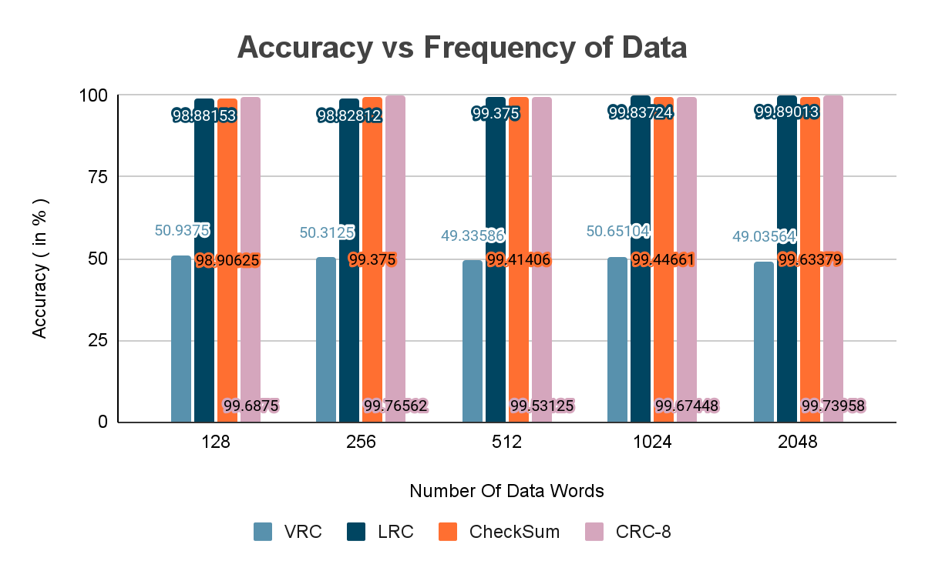

TABLE 2

Scheme | VRC | LRC | CheckSum | CRC-8
Average Accuracy  (in %) | 50.05450 | 99.05484 | 99.35514 | 99.67968

Note: Each cell represents the average accuracy (in %) from TABLE 1.

Graph for TABLE 2

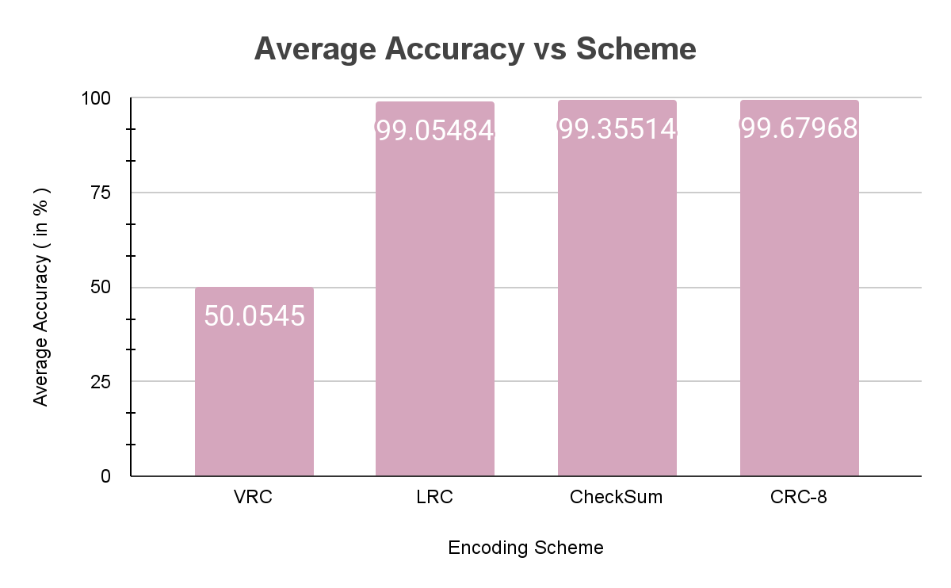

TABLE 3

SCHEME | VRC | LRC | CheckSum | CRC-8
RANGE  (max – min)  (in %) | 1.0186 | 1.0086 | 0.72754 | 0.23435

Note: Each cell represents the range of accuracy (in %) from TABLE 1.

Graph for TABLE 3

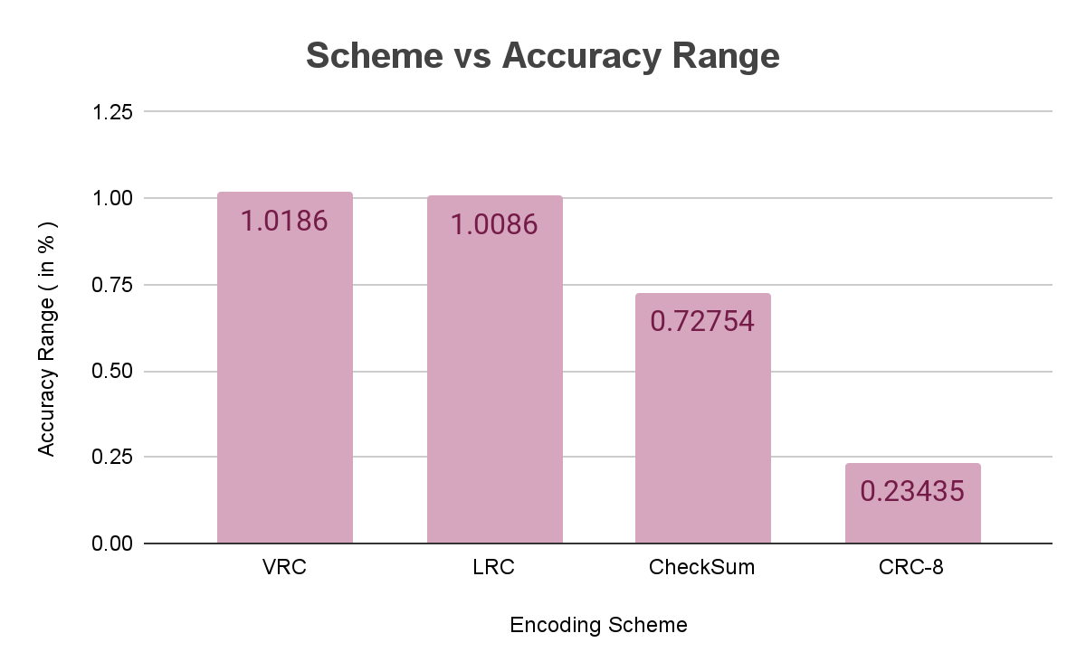

Analysis:

